RAW MATERIAL SAVINGS

When manufacturing a cable, the costs related to the raw material have reached unpredictable summits. Typically, a cable manufacturer pays today around EUR 9'150.00 for a ton of copper and EUR 2'200.00 for a ton of aluminium.

To remain competitive on the market, the cable manufacturers need to control very accurately their raw material consumption, in order to save sales margins. Moreover, due the limited amount of raw material stocks available worldwide, the supply chains needed to be adapted to avoid any problem with the delivery of those raw materials. In other words, a cable manufacturer needs today more than one supplier where to buy copper and aluminium. The obligation to work with different suppliers means that different material qualities will be purchased and consequently different material specifications, which requires a lot of attention when working at the edge of the material consumption.

The only way allowing saving raw material consists in controlling very accurately and constantly the resistance of each manufactured product, by reducing the extra material margin at its absolute strict minimum. To do so, highly accurate and repeatable resistance bridges are required.

Low cost bridges don't do the job anymore. A fragment of a percent additional accuracy or less repeatability means today several thousands of Euros saved or spent every month. Weigh measurements can only be considered with extreme care, as they don't take into account the conductivity of the tested material.

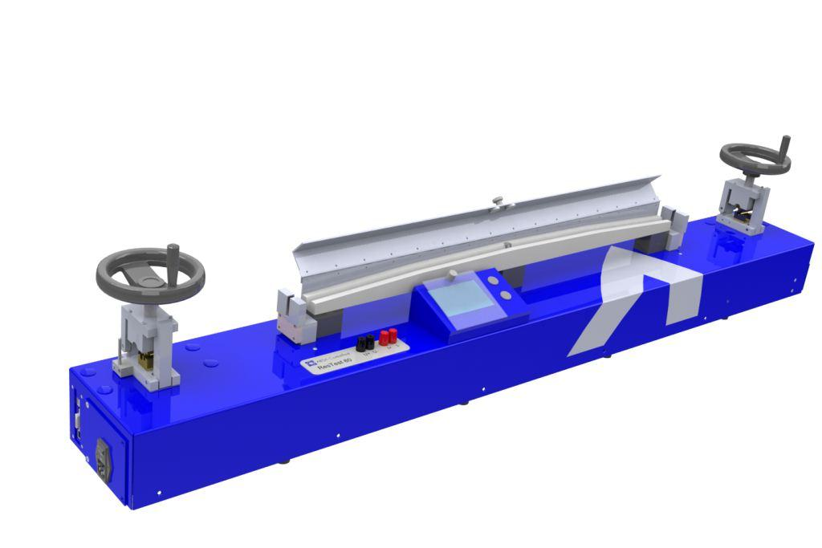
AESA has always been a major player in providing state-of-the-art resistance measurement solutions, for any type of copper and aluminium conductors. Depending on the bridge type, measurements can be taken directly on a stranding line or in a test laboratory.

Different products are available:

The ResTest 50 unit is covering small ranges
up to 50mm²
ResTest 50

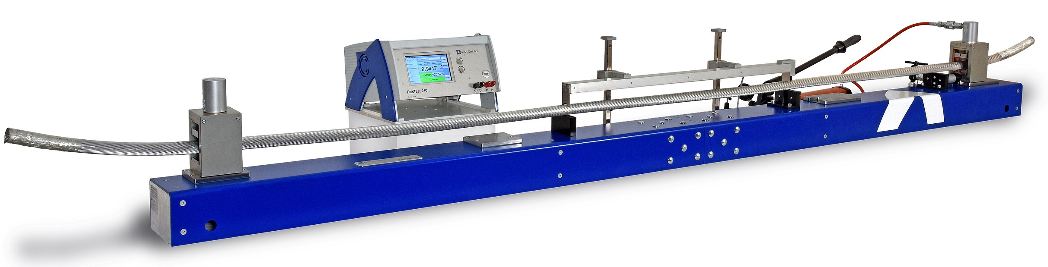
ResTest 210
The ResTest 210 unit is covering the sections up
to 2000mm²
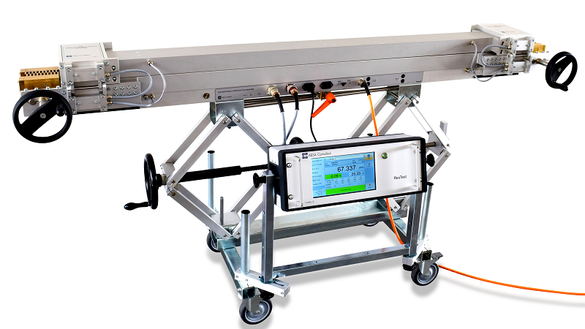

The 8130 family is covering the range
from 2.5mm² to 1800mm²
8130

Please check in our website www.aesa-cortaillod.com the technical characteristics of the above solutions.

Our experience shows that savings are possible in the range of 0.3% to 2% for conductors from 1mm² to 240mm². Potential savings can reach 3% or more on large strands above 240mm².

Calculate your payback time for an AESA resistance bridge depending on the amount of raw material you buy every month and the expected percentage of material you think you can save.


